CSA1717-ARTIFICIAL INTELLIGENCE
PRACTICAL LAB EXPERIMENTS
NIHARIKA PREEJESH (192524506)

PROGRAM 10: MISSIONARIES AND CANNIBALS
Aim: To implement the Missionaries and Cannibals problem using Artificial Intelligence search techniques to safely transport all missionaries and cannibals across the river.
Algorithm:
- Start with all missionaries and cannibals on the left bank.
- Move one or two people across the river using the boat.
- Ensure that on both riverbanks, missionaries are never outnumbered by cannibals (unless no missionaries are present).
- Generate only valid states.
- Continue exploring valid states until the goal state is reached.
- Display the sequence of moves from the initial state to the goal state.

Flowchart:
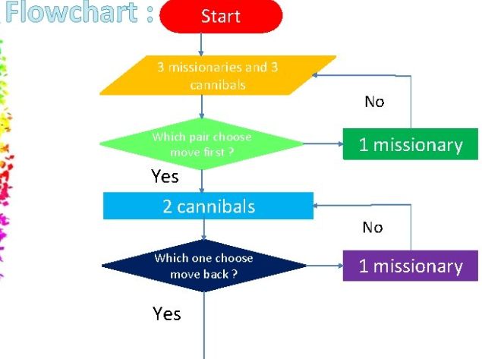
Output:
Initial State:
(3M, 3C, Left)

Goal State Reached:
(0M, 0C, Right)

Solution Found
Result:
Thus, the Missionaries and Cannibals problem was implemented successfully, and all missionaries and cannibals were safely transported across the river without violating the constraints.

